TEMPLATE FOR TYPING THE ABSTRACTS
FOR iNTERNATIONAL CONFERENCE “PTAM-2023”

P.P. Petrov¹, I.I. Ivanov²

¹Institute for Materials Science, New Town, Country
²City State University, Old City, Country
petrov@ims.ru

The abstracts should be typed using Microsoft Word text processor. The file should be named by the surname and initials of the speaker, for example, petrov_pp.doc. In addition, the speaker's initials and surname are underlined in the list of authors. Abstracts, the design of which does not meet this template, will not be accepted. The length of abstracts is 2-3 A4 (29.7×21 cm) pages. The page orientation is portrait. Margins - 2 cm from all sides. The text is typed in Times New Roman font, size 12 pt, line spacing - 1. Paragraph indentation in the main text is 1.25 cm. Figures, if any, are located in the text and are accompanied by captions directly under the figure. Pictures are embedded from files in any graphical format that provides high quality and small amount of required disk space. Literature references are indicated in square brackets and numbered in the order [1, 2]. Formulas are typed in the Microsoft Equation editor (for Microsoft Word 2003) or the standard Microsoft Word formula editor of new versions.

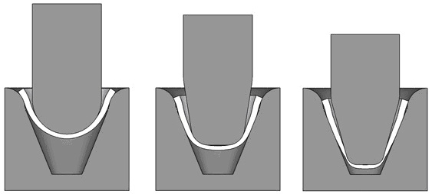
a b c
Fig. 1. Results of modeling of forging into a conical part; the shape of the workpiece after the 1st (a), 2nd (b) and 3rd (c) transition

Table 1. Results of X-ray structural analysis of samples in states 1 and 2

State | D, Å | <ε²>^{1/2}(×10⁻³) | ρ, m⁻²
1 | 300±50 | 9.0±0.08 | 7.0×10¹⁴
2 | 400±50 | 3.0±0.12 | 2.1×10¹⁴

Literature
- R.M. Kashaev, M.I. Nagimov, A.M. Khusnullin // Materials Physics and Mechanics. 2017. No. 33. P. 97-103.
- V.V. Rybin. Large plastic deformations and Fracture of Metals. Moscow: Metallurgy, 1986. 224 p.

